Problem 2
Problems in ERD Diagram Given:

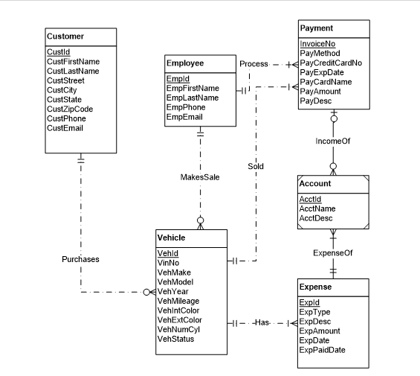

- In MakeSale relationship between Employee and Vehicle, Minimum Cardinality near Employee should be zero as Vehicle Details can be recorded without an employee.
- Vehicle Entity is not having attribute for Transmission Type(automatic or manual)
- Account Should not be a weak entity.
- ExpenseOf Between Account and Expense should be (1,1) near Account and (Optional,Many near Expense),it should be made non-identifying.(Reversed Relationship)
- IncomeOf Between Payment and Account should be (1,1) Near Account , and (Optional,mamy near Payment),it should be made non-identifying. (Reversed Relationship)
- Sold cardinality near Payment should be zero.Vehicle can remain for a lot of days before sale.
- Purchases cardinality Should be zero near customer as vehicle is in stock for a lot of days before sales.
- Process relationship between Employee and Payment does not mean anything.
